DESIGN AND ANALYSIS OF ALGORITHM

Subject Code: CONT_22CAP-654 Experiment No. 1.2

Student Name: RANJITA SETHI UID: 22MCA20926
Section/Group: 22MCA/7(B) Semester: 2ND
Date of Submission: 01/03/2023

Aim/Overview of the practical :

Implement merge sort algorithm to sort a given set of elements and determine the time required to sort the elements. Repeat the experiment for different values of n, the number of elements in the list to be sorted and plot a graph of the time taken versus n. The elements can be read from a file or can be generated using the random number generator.

  - PROGRAM LOGIC: Merge Sort is a Divide and Conquer algorithm. It divides input array in two halves, calls itself for the two halves and then merges the two sorted halves. The merge() function is used for merging two halves. The merge(a, low, mid, high) is key process that assumes that a[low..mid] and a[mid+1..high] are sorted and merges the two sorted sub-arrays into one.

PROCEDURE:

- Create: Open Dev C++, write a program after that save the program with .cpp extension.

- Compile: Alt + F9

- Execute: Ctrl + F10

#Algorithm :

- If p<r
- Then q → ( p+ r)/2
- MERGE-SORT (A, p, q)
- MERGE-SORT ( A, q+1,r)
- MERGE ( A, p, q, r)
- FUNCTIONS: MERGE (A, p, q, r) 7. n 1 = q-p+1
8. n 2= r-q
9. create arrays [1.....n 1 + 1] and R [ 1. n 2 +1 ]
10. for i ← 1 to n 1
11. do [i] ← A [ p+ i-1]

- for j ← 1 to n2
- do R[j] ← A[ q + j]

14. L [n 1+ 1] ← ∞
15. R[n 2+ 1] ← ∞
16. I ← 1
17. J ← 1
- For k ← p to r
- Do if L [i] ≤ R[j]
- then A[k] ← L[ i]
21. i ← i +1
22. else A[k] ← R[j]
23. j ← j+1

  - SOURCE CODE:

#include <stdio.h>

#include <stdlib.h> #include

<time.h>

void merge(int arr[], int l, int m, int r) { int i, j, k;
int n1 = m - l + 1; int n2 = r - m; int L[n1], R[n2];

for (i = 0; i < n1; i++) L[i] = arr[l + i]; for (j = 0; j < n2; j++) R[j] =
arr[m + 1 + j]; i = 0;
j = 0;

k = l;

while (i < n1 && j < n2) {

if (L[i] <= R[j]) {

arr[k] = L[i]; i++;

} else { arr[k] =

R[j]; j++; } k++;
}

while (i < n1) { arr[k] = L[i];
i++; k++;

}

while (j < n2) { arr[k] = R[j];
j++; k++;

}

} void mergeSort(int arr[], int l, int r)

{

if (l < r) { int m = l + (r - l) / 2; mergeSort(arr, l, m); mergeSort(arr, m
+ 1, r); merge(arr, l, m, r);
}

}

int main() { int n, i;

clock_t start, end; double time_taken; printf("Enter the number of elements: "); scanf("%d", &n);
int arr[n];

printf("Enter %d elements:\n", n); for (i = 0; i < n; i++) {
scanf("%d", &arr[i]);

}

start = clock(); mergeSort(arr, 0, n - 1); end
= clock(); printf("Sorted array:\n"); for (i = 0; i < n;
i++) { printf("%d ", arr[i]);
}

printf("\n");

time_taken = ((double)(end - start)) / CLOCKS_PER_SEC; printf("Time taken to sort %d elements is %f seconds.\n", n, time_taken);
return 0;

}

Output:

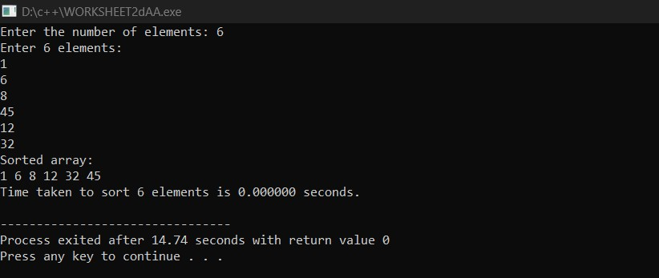

Learning outcomes (What I have learned):

    - The objective of the merge sort algorithm is to sort an array or a list of elements in ascending or descending order. It achieves this by dividing the input into smaller halves, recursively sorting each half, and then merging the sorted halves back together. The merging process involves comparing elements from each half and arranging them in the correct order.
    - The primary advantage of merge sort is that it has a time complexity of O(n log n), which is much faster than many other sorting algorithms in the worst-case scenario. Additionally, merge sort is a stable sorting algorithm, meaning that it maintains the relative order of equal elements in the input array.
    - Overall, the objective of merge sort is to provide an efficient, stable, and reliable way to sort a list of elements.

